**AIM:**

Demonstrate use of shared preferences/ internal storage to store app data.

XML Code:

<?xml version="1.0" encoding="utf-8"?>

<RelativeLayout xmlns:android="http://schemas.android.com/apk/res/android"

android:layout_width="match_parent"

android:layout_height="match_parent"

android:padding="16dp">

<EditText

android:id="@+id/editTextUsername"

android:layout_width="match_parent"

android:layout_height="wrap_content"

android:hint="Username" />

<EditText

android:id="@+id/editTextName"

android:layout_width="match_parent"

android:layout_height="wrap_content"

android:hint="Name"

android:layout_below="@id/editTextUsername"

android:layout_marginTop="8dp" />

<EditText

android:id="@+id/editTextAge"

android:layout_width="match_parent"

android:layout_height="wrap_content"

android:hint="Age"

android:layout_below="@id/editTextName"

android:layout_marginTop="8dp" />

<EditText

android:id="@+id/editTextBloodType"

android:layout_width="match_parent"

android:layout_height="wrap_content"

android:hint="Blood Type"

android:layout_below="@id/editTextAge"

android:layout_marginTop="8dp" />

<EditText

android:id="@+id/editTextContact"

android:layout_width="match_parent"

android:layout_height="wrap_content"

android:hint="Contact Number"

android:layout_below="@id/editTextBloodType"

android:layout_marginTop="8dp" />

<Button

android:id="@+id/buttonAdd"

android:layout_width="wrap_content"

android:layout_height="wrap_content"

android:text="ADD"

android:layout_below="@id/editTextContact"

android:layout_marginTop="16dp" />

<Button

android:id="@+id/buttonFetch"

android:layout_width="wrap_content"

android:layout_height="wrap_content"

android:text="FETCH"

android:layout_below="@id/buttonAdd"

android:layout_marginTop="8dp" />

</RelativeLayout>

Main JAVA Code:

package com.example.practical7;import android.content.SharedPreferences;

import android.os.Bundle;

import android.util.Log;

import android.view.View;

import android.widget.Button;

import android.widget.EditText;

import android.widget.Toast;

import androidx.appcompat.app.AppCompatActivity;

public class MainActivity extends AppCompatActivity {

private EditText editTextUsername, editTextName, editTextAge, editTextBloodType, editTextContact;

private Button buttonAdd, buttonFetch;

private SharedPreferences sharedPreferences;

@Override

protected void onCreate(Bundle savedInstanceState) {

super.onCreate(savedInstanceState);

setContentView(R.layout.*activity_main*);

editTextUsername = findViewById(R.id.*editTextUsername*);

editTextName = findViewById(R.id.*editTextName*);

editTextAge = findViewById(R.id.*editTextAge*);

editTextBloodType = findViewById(R.id.*editTextBloodType*);

editTextContact = findViewById(R.id.*editTextContact*);

buttonAdd = findViewById(R.id.*buttonAdd*);

buttonFetch = findViewById(R.id.*buttonFetch*);

// Initialize SharedPreferences

sharedPreferences = getSharedPreferences("BloodBankPrefs", *MODE_PRIVATE*);

// Set OnClickListener for the ADD button

buttonAdd.setOnClickListener(new View.OnClickListener() {

@Override

public void onClick(View v) {

String username = editTextUsername.getText().toString().trim();

String name = editTextName.getText().toString().trim();

String age = editTextAge.getText().toString().trim();

String bloodType = editTextBloodType.getText().toString().trim();

String contact = editTextContact.getText().toString().trim();

if (username.isEmpty()) {

Toast.*makeText*(MainActivity.this, "Username cannot be blank", Toast.*LENGTH_SHORT*).show();

} else {

SharedPreferences.Editor editor = sharedPreferences.edit();

editor.putString(username + "_name", name);

editor.putString(username + "_age", age);

editor.putString(username + "_bloodType", bloodType);

editor.putString(username + "_contact", contact);

editor.apply();

Toast.*makeText*(MainActivity.this, "Details saved successfully", Toast.*LENGTH_SHORT*).show();

}

}

});

// Set OnClickListener for the FETCH button

buttonFetch.setOnClickListener(new View.OnClickListener() {

@Override

public void onClick(View v) {

String username = editTextUsername.getText().toString().trim();

if (username.isEmpty()) {

Toast.*makeText*(MainActivity.this, "Username cannot be blank", Toast.*LENGTH_SHORT*).show();

} else {

String name = sharedPreferences.getString(username + "_name", null);

String age = sharedPreferences.getString(username + "_age", null);

String bloodType = sharedPreferences.getString(username + "_bloodType", null);

String contact = sharedPreferences.getString(username + "_contact", null);

Log.*d*("MainActivity", "Fetched Data: " + name + ", " + age + ", " + bloodType + ", " + contact);

if (name != null) {

editTextName.setText(name);

editTextAge.setText(age);

editTextBloodType.setText(bloodType);

editTextContact.setText(contact);

} else {

Toast.*makeText*(MainActivity.this, "Username does not exist", Toast.*LENGTH_SHORT*).show();

}

}

}

});

}

}

**Output:**

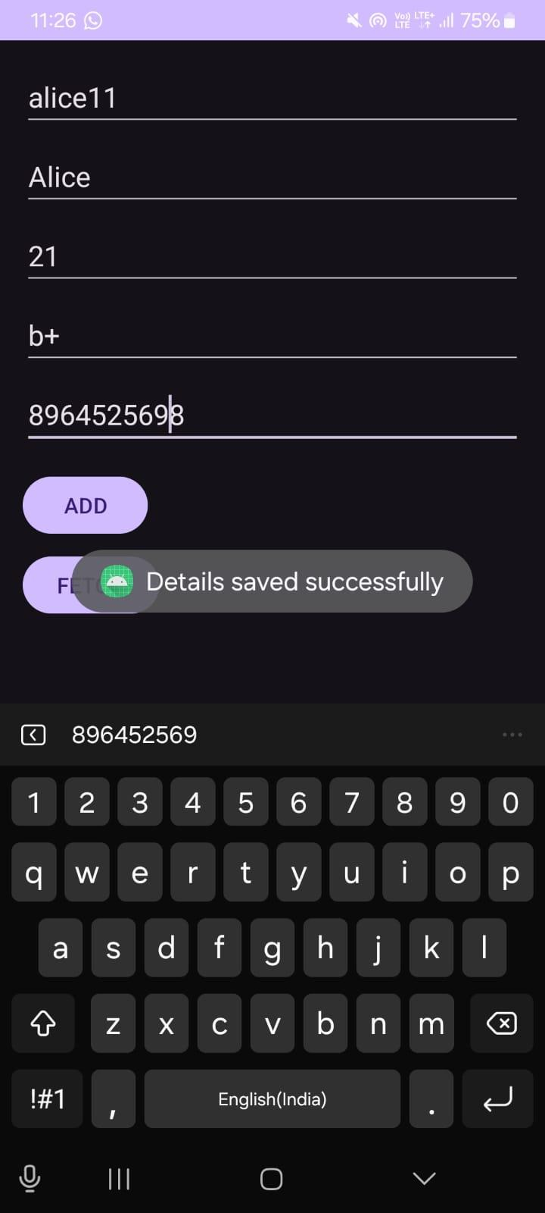

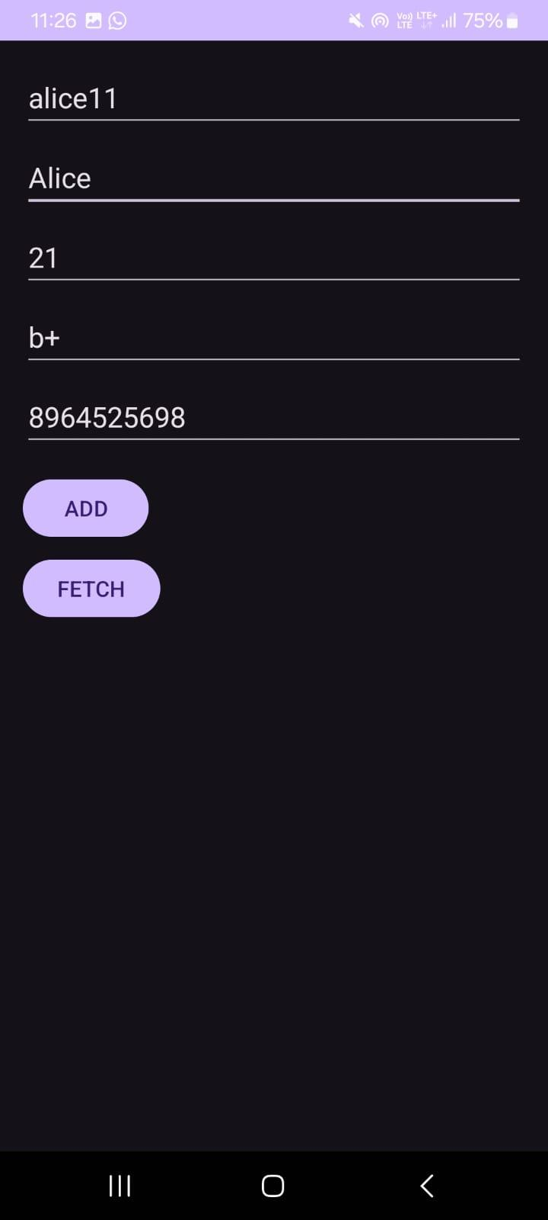

**CONCLUSION:**

In this practical, we developed a simple Android application for a blood bank registration system that utilizes Shared Preferences for persistent data storage. The app allows users to input and save their details, such as username, name, age, blood type, and contact information, while also providing functionality to retrieve and display this information based on the username. Through this project, we gained valuable insights into handling user input, implementing data validation, and debugging with logging techniques. Overall, this exercise not only reinforced our understanding of Android app development but also highlighted the importance of efficient data management in creating user-friendly applications.